**Web Technonolgy & Information Security**

**Computer Department**

**“MediTrack System”**

**“Enhancing Healthcare Efficiency and Security Through**

**Digital Medical Records "**

**Prepared by:**

Jumana.M.Lubbad (2041091050)

Dina.E.Zaqout (2041091051)

Lama.N.Eleyan (2041091057)

Lama.A.Al-Najjar (2041091073)

**Supervised by:**

Dr. Mayada Al Meghari

1 𝑠𝑡 semester 2024/2025

**Table of Contents**

| **Topic** | **Page** |
| --- | --- |
| Abstract ……………………………………………………………………... | 3 |
| 1. Introduction ……………………………………………………………… | 4 |
| 1.1 Problem Statement ……………………………………………………. | 4 |
| 1.2 Objectives ……………………………………...……………………... | 5 |
| 1.2.1 Main Objectives …………………………………………………. | 5 |
| 1.2.2 Specific Objectives ……………………………………………… | 5 |
| 1.3 Importance of the Project …………...………………………………... | 6 |
| 1.4 Scope and Limitations of the Project ………………………………… | 6 |
| 1.4.1 Project Scope ………………………………...………………... | 6 |
| 1.4.2 Project Limitations …………………………………………….. | 7 |
| 2. State of the Art / Review of Related Works ……………………………... | 8 |
| 3.Methodology ……………………………………………………………… | 11 |
| 3.1 Project Methods ……………………………………………………... | 11 |
| 3.2 Software Tools and Equipment Requirement ………………………. | 13 |
| 3.3 Time Table ………………………………………………………….. | 15 |
| 4. Bibliography ……………………………………………………………... | 17 |

**Abstract**

The ongoing war in Gaza has created a devastating humanitarian crisis, with the healthcare system suffering massive destruction and pharmaceutical supply chains facing severe disruptions. Thousands of civilians, including children, the elderly, and patients with chronic illnesses, are left without access to essential medications. This project proposal presents a comprehensive plan to establish a sustainable and resilient pharmacy system that addresses both the immediate and long-term pharmaceutical needs of the population.

The project aims to secure a steady supply of essential medicines, support the restoration of local pharmacies and medical centers, and develop efficient, conflict-adaptive distribution mechanisms. It will also strengthen emergency medical response capabilities to ensure rapid access to life-saving drugs during critical situations. Strategic collaboration with local authorities, humanitarian organizations, and international partners will be central to the project’s implementation, ensuring coordination, resource optimization, and greater reach.

In addition, the project will explore long-term solutions such as localized pharmaceutical production and the creation of secure supply routes to reduce dependence on external aid. By addressing logistical, financial, and security challenges, this pharmacy initiative serves as a vital step toward rebuilding Gaza’s healthcare resilience and safeguarding public health under extreme conditions.

### **Keywords:** Pharmacy System, Humanitarian Crisis, Essential Medicine, Conflict Zone Healthcare

**1. Introduction**

The ongoing war in Gaza has caused immense suffering, leaving countless individuals without access to essential medical care and pharmaceuticals. The destruction of healthcare facilities, supply chain disruptions, and the displacement of thousands have intensified the need for an urgent, sustainable, and efficient solution to provide life-saving medications to those in need.

This proposal aims to establish a pharmacy project that will serve as a critical lifeline for affected communities by ensuring a steady and accessible supply of essential medicines. Our initiative focuses on sourcing, distributing, and managing pharmaceutical supplies to support hospitals, clinics, and displaced populations. We will work in collaboration with local and international organizations to streamline efforts, minimize shortages, and ensure that even in the most challenging conditions, people receive the medications they desperately need.

By implementing a structured and community-driven approach, this project seeks not only to provide immediate relief but also to lay the foundation for a resilient pharmaceutical system that can withstand ongoing and future crises.

**1.1 Problem Statement**

The ongoing war in Gaza has severely disrupted the healthcare system, leaving thousands of people without access to essential medicines and life-saving treatments. The destruction of hospitals, pharmacies, and supply chains has created an acute shortage of pharmaceuticals, placing countless lives at risk, especially among the wounded, chronically ill, children, and the elderly.

Humanitarian aid efforts face significant challenges due to infrastructure damage, blockades, and logistical barriers, making it nearly impossible to maintain a consistent and reliable flow of medical supplies. Pharmacies that once served as vital access points for medications have either been destroyed or are struggling with stock depletion, pricing instability, and security risks. As a result, patients with chronic illnesses such as diabetes, hypertension, and respiratory diseases, as well as those requiring urgent medical attention, are left untreated, leading to preventable complications and fatalities.

Without immediate intervention, the situation will continue to deteriorate, resulting in a public health catastrophe. There is an urgent need for a sustainable and adaptive pharmaceutical system that can overcome these challenges, ensuring that essential medicines reach those in need despite the ongoing crisis. This proposal seeks to address these pressing issues by establishing a structured, resilient, and efficient pharmacy project that prioritizes accessibility, affordability, and continuity of care in Gaza.

**1.2 Objectives**

In this section, we present the main and specific objectives of the proposed project as follows:

**1.2.1 Main Objective**

To establish a sustainable pharmacy system that ensures continuous access to essential medicines for the people of Gaza, overcoming supply chain disruptions and addressing urgent healthcare needs amid the ongoing war.

**1.2.2 Specific Objectives**

1- Ensure Medicine Supply – Secure and distribute essential medications to hospitals, clinics, and affected communities.

2- Develop Efficient Logistics – Overcome transportation and distribution challenges caused by the conflict.

3- Support Healthcare Facilities – Assist pharmacies, hospitals, and clinics in maintaining operations.

4- Improve Accessibility & Affordability – Ensure medicines are available and affordable for vulnerable groups.

5- Enhance Emergency Response – Provide rapid medical supply distribution for urgent cases.

6- Collaborate with Humanitarian Organizations – Partner with NGOs and agencies for resource optimization.

**1.3 Importance of the project**

The pharmacy project is vital in addressing the severe healthcare crisis in Gaza, where war has devastated medical infrastructure and disrupted access to essential medicines. With hospitals and pharmacies struggling to function, this initiative will provide a lifeline to thousands in need.

By ensuring a reliable supply of medications, the project will help prevent avoidable deaths, manage chronic illnesses, and support emergency medical response. It will also strengthen healthcare resilience by developing sustainable supply chains and fostering collaboration with humanitarian organizations.

Beyond immediate relief, this project lays the foundation for a more stable and self-sufficient pharmaceutical system, ensuring long-term healthcare accessibility for Gaza’s population.

**1.4 Scope and Limitations of the Project**

This section offers the scope and the limitations of the proposal research project as shown below:

#### **1.4.1 Project Scope:**

* **Medicine Supply & Distribution** – Ensure the availability and delivery of essential medicines to hospitals, clinics, and affected communities.
* **Support for Healthcare Facilities** – Assist pharmacies and medical centers in restocking and operating under crisis conditions.
* **Emergency Medical Response** – Provide rapid access to critical medications for urgent and life-threatening cases.
* **Collaboration & Sustainability** – Partner with humanitarian organizations and explore long-term solutions like local production.

#### **1.4.2 Project Limitations:**

* **Logistical Challenges** – Movement restrictions and damaged infrastructure may delay distribution.
* **Supply Shortages** – Limited access to imports may impact medicine availability.
* **Security Risks** – Ongoing conflict poses threats to transportation and operations.
* **Funding Constraints** – Reliance on external support may affect project sustainability.

**2. Related Work**

In this section, we present some of the web applications related to the proposal project. These applications are shown below:

**1-** PillPack [1]: Amazon Pharmacy simplifies prescription medication management by organizing pills into pre-sorted pouches with clear labels for each dose. Here's a quick overview[1]:

* Pre-Sorted Doses: Medications are packed by dose, making it easy to take the right medicine at the right time.
* Free Delivery: Medications are delivered directly to your door, with free shipping.
* Automatic Refills: PillPack handles refills and updates prescriptions automatically.
* 24/7 Support: Access pharmacists and support anytime.
* Amazon Integration: Offers pricing benefits for Amazon Prime members.  
  - Figure 1 shows the knowledge PillPack site

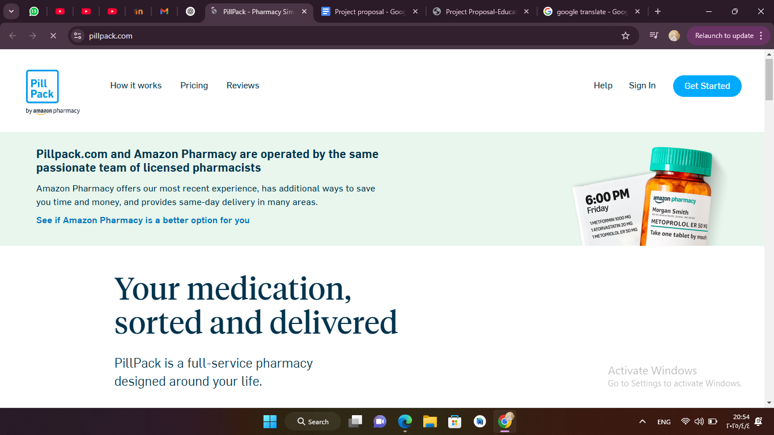

Figure 1 : PillPack Application [1]

**2-** Pharmalex : is a global provider of regulatory affairs, quality assurance, and consulting services for the pharmaceutical, biotechnology, and medical device industries. The company focuses on helping clients navigate the complex regulatory landscape and optimize product development processes [2]. Key services include:

* Regulatory Affairs: Pharmalex offers expert guidance on regulatory submissions, approvals, and market access across global markets.
* Quality Assurance: The company ensures that pharmaceutical and biotechnological products comply with international standards and quality regulations.
  + Consulting Services: Pharmalex provides tailored solutions for pharmaceutical companies, aiding them in achieving regulatory compliance, accelerating product development, and improving operational efficiency. Figure 2 shows the knowledge Pharmalex site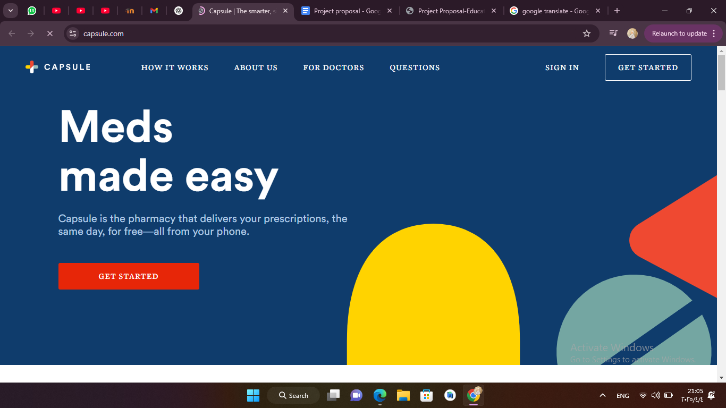

Figure 2: Pharmalex Application [2]

3.Medisafe:Medisafe is a free app that helps users remember medication schedules accurately, widely used by patients and caregivers [3]:

Custom Alerts: Sends notifications based on each user's medication schedule.

Drug Interaction Warnings: Alerts the user if there are medications that might negatively interact with each other.

Report Sharing: Users can share medication adherence reports with doctors or family.

Multiple Profiles: Supports managing medications for family members through separate accounts.

Cloud Synchronization: Stores and syncs data across devices.

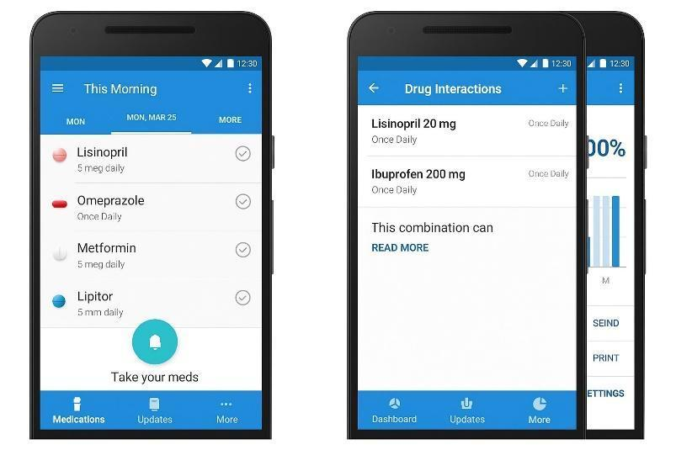

Figure 3 shows the Medisafe app interface.[3]

4.OpenEMR:OpenEMR is an open-source electronic medical records (EMR) management system used by clinics and healthcare institutions worldwide [4]:

Electronic Medical Records: Efficiently manages patient data.

Appointment Management: Allows easy scheduling and organizing of patient appointments.

Billing Setup: Supports medical billing and insurance claims.

Multilingual Support: Available in multiple languages to expand usage.

Secure and Customizable: Provides high security and can be customized to meet institutional needs.

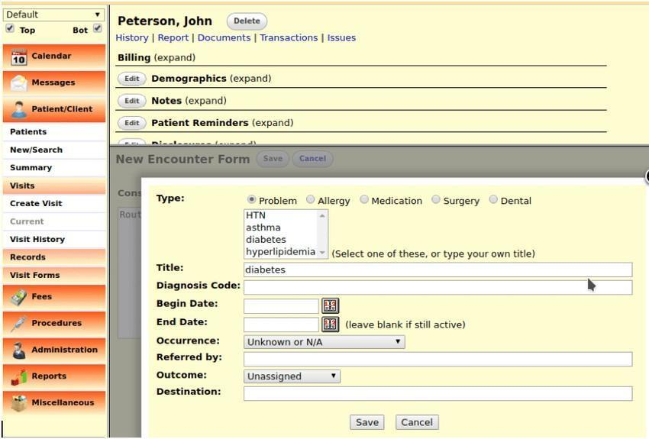

Figure 4 shows the OpenEMR system interface.[4]

### **3. Methodology**

The methodology outlines the approach used to achieve the study's objectives. It includes the research design, data collection methods (such as surveys, experiments, or observational studies), sampling strategies, and data analysis techniques. Ethical considerations, such as informed consent and confidentiality, are also addressed. This structured approach ensures the research is systematic, valid, and reproducible.

**3.1 Theories and Methods:**

Our proposed methodology follows an incremental model, allowing for continuous development and refinement of the project. This iterative approach helps ensure flexibility, adaptability, and constant user feedback throughout the process. The methodology consists of the following steps:

1. Research and Analysis: Investigate the existing pharmacy systems, identify user needs, analyze current challenges, and evaluate technological constraints and best practices in pharmaceutical services.
2. Requirement Definition: Based on the research findings, define the scope, features, and functional requirements of the pharmacy system.
3. Design & Development: Design the system architecture, user interfaces, and begin developing features incrementally, ensuring each step adds value.
4. Testing and Optimization: Test each increment for functionality, user experience, and performance, incorporating feedback for continuous improvement.
5. Deployment and Maintenance: After the platform is launched, ensure ongoing maintenance and regular updates to keep the system aligned with user needs and industry advancements.

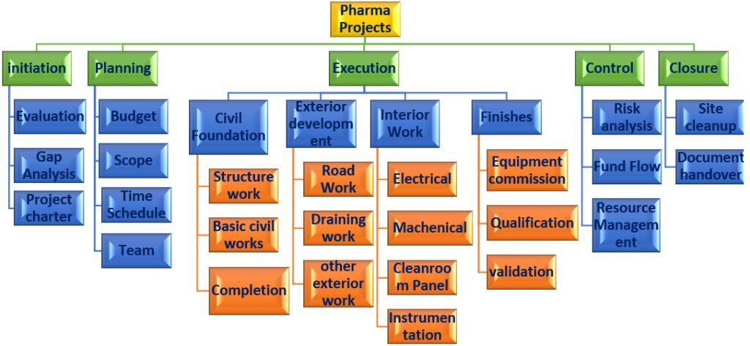

Figure 5: Steps of Project Methodology[5]

### **3.2 System Architecture Diagram**

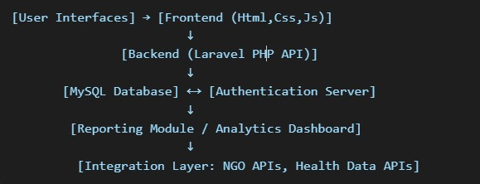

#### **3.3 Use Case Diagram Description**

### Actors: Patient, Doctor, Pharmacist, NGO, Admin Use Cases: Register patient, Add prescription, View medication schedule, Approve medicine request, Track distribution, Generate report

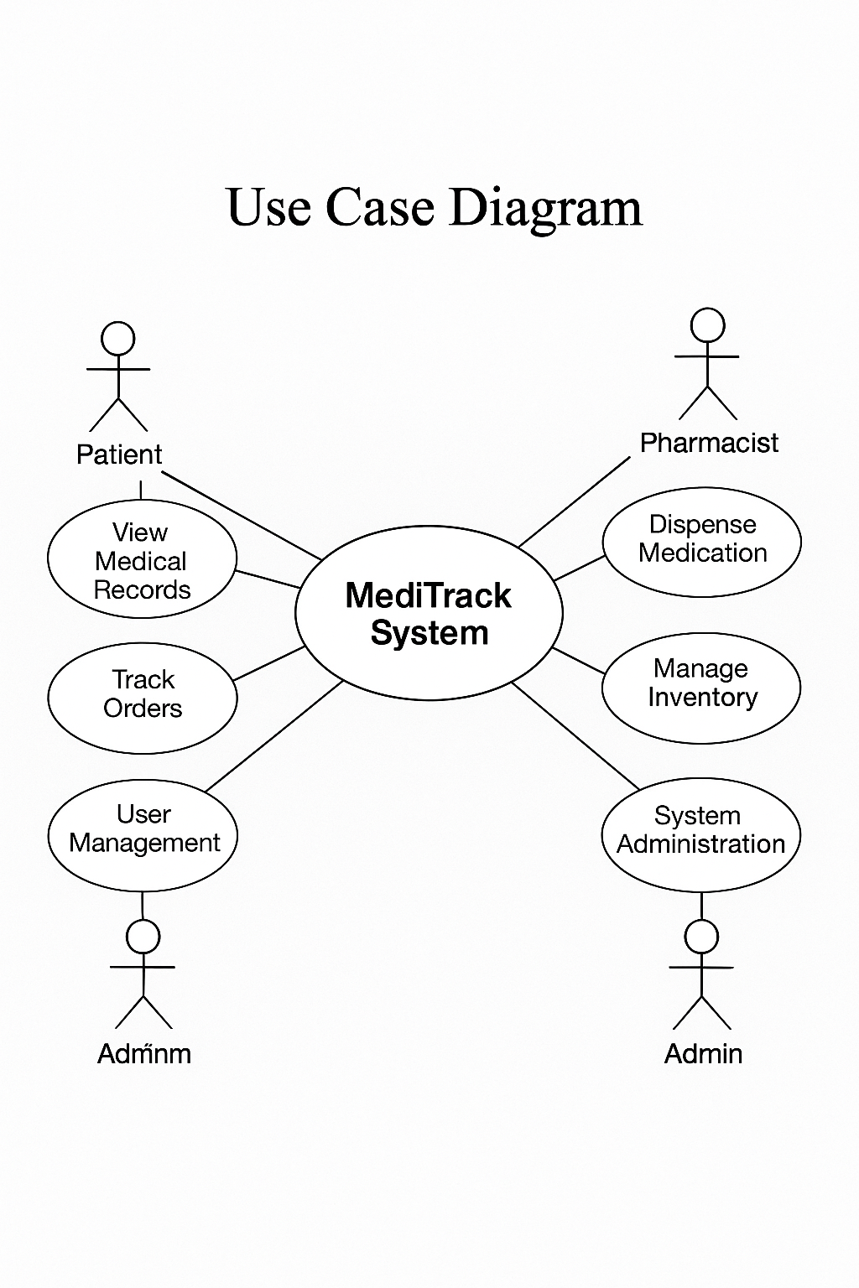

### **3.4 Software Tools and Equipment Requirements**

For the development of our pharmacy system, we will utilize the following software tools and equipment to ensure efficient creation, deployment, and maintenance of the platform:

1. **Development Tools**:  
   * **Frontend**: HTML, CSS, JavaScript (for designing the user interface and creating responsive, interactive elements)
   * **Backend**: PHP with Laravel framework (to manage the server-side logic, APIs, and data processing)
2. **Database Management**:  
   * **phpMyAdmin**: Used for managing the MySQL database, ensuring efficient handling of data and queries for the system.
3. **IDE/Code Editors**:  
   * **Visual Studio Code**: A versatile code editor that supports frontend and backend development with various extensions and tools for efficient coding.
   * **Cursor**: An additional code editor for managing backend development tasks.
4. **Version Control**:  
   * **Git**: To track and manage changes to the project’s codebase and collaborate among team members.
   * **GitHub**: To store the project in a remote repository, allowing for version management, collaboration, and deployment.
5. **Deployment Tools**:  
   * **Hostinger**: A web hosting service that will be used to deploy the pharmacy platform, ensuring it is accessible online and can be maintained effectively.
6. **Equipment Requirements**:  
   * **Developer Workstation**:  
     + **Processor**: Intel Core i5 or equivalent
     + **RAM**: Minimum of 4GB (8GB recommended for optimal performance during development)
     + **Storage**: 256GB SSD (Solid State Drive) minimum for fast data access and smooth development.
   * **Internet Connection**:  
     + A reliable broadband connection will be necessary for development, testing, and deployment activities, ensuring smooth collaboration and access to cloud-based services.

### **4. Cybersecurity Strategy**

Given the sensitivity of health data, MediTrack will include:

* **Role-based Access Control:** Separate permissions for patients, doctors, pharmacists, and NGOs.
* **Data Encryption:** AES-256 for stored records; TLS for transmission.
* **Audit Trails:** All activity logged for traceability.
* **Backup Systems:** Automated daily backups.
* **Disaster Recovery Plan:** Offline data export capability in case of cyberattacks

**5 Software time management chart**

This chart presents a carefully organized 8-month plan for an academic software project, structured according to best practices in software engineering. Each phase—from idea generation and problem analysis to final presentation—is assigned a specific duration to ensure clarity and smooth project flow. This strategic distribution of tasks promotes balanced progress, reduces bottlenecks, and allows sufficient time for testing, documentation, and final improvements. As an academic project, this timeline helps the team effectively manage their efforts, stay on track, and achieve both learning and implementation goals within the allocated period.

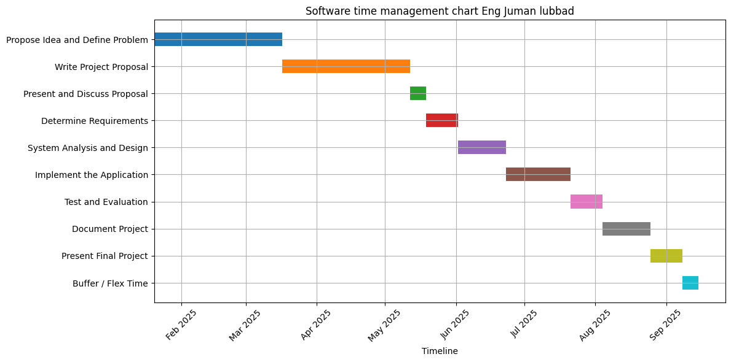

### 

### 

### 

### **📋 Project Phases and Duration**

| **No.** | **Phase** | **Duration** |
| --- | --- | --- |
| **1** | **Propose Idea and Define Problem** | **8 weeks** |
| **2** | **Write Project Proposal** | **8 weeks** |
| **3** | **Present and Discuss Proposal** | **1 week** |
| **4** | **Determine Requirements** | **2 weeks** |
| **5** | **System Analysis and Design** | **3 weeks** |
| **6** | **Implement the Application** | **4 weeks** |
| **7** | **Test and Evaluation** | **2 weeks** |
| **8** | **Document Project** | **3 weeks** |
| **9** | **Present Final Project** | **2 weeks** |
| **10** | **Buffer / Flex Time** | **1 weeks** |

### **6. Conclusion**

MediTrack offers a holistic solution to one of Gaza's most pressing crises—access to reliable healthcare under siege. By digitizing patient care and building a resilient pharmaceutical logistics system, MediTrack empowers healthcare workers, improves patient outcomes, and contributes to sustainable development under extraordinary conditions.

**7. Bibliography**

[1] PillPack by Amazon Pharmacy. (2025). Online pharmacy services and management. Retrieved from<https://www.pillpack.com/>.

[2] Medly Pharmacy. (2025). Prescription delivery and management services. Retrieved from<https://www.medlypharmacy.com/>.

[3] Pharmalex. (2025). Pharmaceutical services and regulatory solutions. Retrieved from<https://www.pharmalex.com/>.

[4] MedlinePlus. (2025). Drug information and healthcare resources. Retrieved from<https://medlineplus.gov/>.

[5] U.S. Food and Drug Administration. (2025). Drug approvals and regulatory information. Retrieved from<https://www.fda.gov/>.

1. URL: <https://www.pillpack.com/>